|  |  |  |
| --- | --- | --- |
| **The islamic University of Gaza**  **Faculty of IT** |  | **الجامعة الإسلامية بغزة**  **كلية تكنولوجيا المعلومات** |

**Aman: Emergency Medical System for Palestine**

**أمان: نظام الطوارئ الطبي لفلسطين**

**By**

**Anas Mousa Al-Hadadd 120211742**

**Rafiq xxxxx Al-Dahshan 120212190**

**Amer Hesham Al-Bashity 120212380**

**Hamza Ali Al-Baghdady 120210634**

**Supervised by**

**Dr. Ashraf xxxx Al-Mghary**

**A graduation project report submitted in partial**

**fulfillment of the requirements for the degree of**

**Bachelor of Information Technology**

**June/2025**

**Abstract**

(Time New Romans, font size 14, bold B)

(Within one page)

**This Abstract should be written in a paragraph base not as points bases.**

**Notes: you must remove or replace any text in red in the report**

This template is in the correct format - just type over it and save it as your document.

The first item in your thesis should be an abstract of a few short paragraphs (within one page) summarising the thesis.

It is suggested that the abstract be structured as follows:

**Problem:** What you tackled, and why this needed a solution

**Objectives and aims:** What you set out to achieve, and how this addressed the problem

**Methodology:** How you went about solving the problem

**Results:** What you managed to achieve, and how far it meets your objectives.

**Conclusions & Recommendations:** The most important finding (in one or two sentences)

From the abstract, a reader should be able to ascertain if the project is of interest to her/him.

**ملخص الدراسة**

(Simplified Arabic , font size 14, bold B)

**(لا يزيد عن صفحة واحدة (عربي))**

# Dedication

(Time New Romans, font size 14, bold B)

(Within one page)

Time New Romans, font size 12.

# Acknowledgment

(Time New Romans, font size 14, bold B)

(Within one page)

Time New Romans, font size 12.

# Table of Contents

Automatic Table of Contents

**Dedication 4**

**Acknowledgment 5**

**Table of Contents 6**

**List of Tables 7**

**List of Figures 8**

**List of Abbreviations 9**

[**Chapter 1  
Introduction 1**](#_heading=h.4d34og8)

[**Chapter 1  
Introduction 2**](#_heading=h.2s8eyo1)

1.1 Problem Statement 2

1.2 Objectives 2

1.2.1 Main Objective 2

1.2.2 Sub Objectives 2

1.3 Scope and Limitations 3

1.4 Importance of the project 3

1.5 Tables 3

1.6 Figures 4

[**Chapter 2  
Related Works 5**](#_heading=h.3j2qqm3)

[**Chapter 3  
Methodology 6**](#_heading=h.1y810tw)

[**Chapter #  
Chapter Name 9**](#_heading=h.2xcytpi)

[**Chapter #  
Chapter Name 10**](#_heading=h.uy4pej9k9eqi)

[**Chapter #  
Chapter Name 11**](#_heading=h.pcmotl8yr2o9)

[**Chapter #  
Conclusions and future works 12**](#_heading=h.1ci93xb)

**References 13**

**Appendix 1: Information on Appendices 15**

# List of Tables

**Table (1):** Number of Laptop vs. Mobile Users (2021-2023) 3

**Table (2):** Test cases runner customization parameters. 3

# List of Figures

**Figure (1):** Average time on site (mobile vs desktop) 5

# List of Abbreviations

|  |  |
| --- | --- |
| **CUT** | Class Under Test |
| **RTS** | Regression Test Selection |
| **SUT** | System Under Test |
| **TDD** | Test Driven Development |
|  |  |
|  |  |
|  |  |
|  |  |
|  |  |
|  |  |
|  |  |
|  |  |
|  |  |
|  |  |
|  |  |
|  |  |
|  |  |
|  |  |

*Note: Sort Alphabetically

يتم عمل مرآة فصل لجميع الفصول

# Chapter 1 Introduction

(Time New Romans, font size 36, bold B)

# Chapter 1 Introduction

This chapter is the start of the main body of the project and should be numbered page 1. Each new chapter should start on a new page. Chapters are entered using the Heading 1 paragraph style. The Heading 1 style automatically moves to the start of a new page, and supplies the next chapter number.

Use the Body Text paragraph style (like this one, with 11 point Times New Roman, 1.5 line spacing, single-sided pages). If you need to use quotes, preferably use single curly quotes ‘…’. If you wish to emphasise something, usually use italic font.

This chapter should include information about the following:

Give the background to your project and context of what you have done to set the scene for the project and grab the reader’s interest early. Sections are entered using the Heading 2 paragraph style – the Heading 2 style automatically supplies the next section number.

## 1.1 Problem Statement

The problem statement should describe **what you tackled, and why it needed a solution**.

## 1.2 Objectives

In the Objectives section, you should outline **what you set out to achieve, and how this addressed the problem** stated in the Problem Statement. The main objective is the overall goal of the project. Sub objectives are the smaller, more specific steps that need to be achieved in order to reach the main objective.

### 1.2.1 Main Objective

### 1.2.2 Sub Objectives

## 1.3 [Scope](http://www.cs.stir.ac.uk/~kjt/research/conformed.html) and Limitations

In the Scope and Limitations section, you should define the boundaries of your project. This includes what you will and will not do, as well as any potential constraints or restrictions that could impact your work.

## 1.4 Importance of the project

In the "Importance of the Project" section, you should explain the significance and potential benefits of your project. This could include its impact on the field, its potential for practical application, or its contribution to knowledge.

## 1.5 Tables

The caption: should be included in the table as the first row formatted like this:

**Table (Chapter number. Table number):** The title of the table (Time New Romans, font size 12.)

**Example:**

**Table (1): Number of Laptop vs. Mobile Users (2021-2023)**

|  |  |  |
| --- | --- | --- |
| **Year** | **Laptop Users** | **Mobile Users** |
| **2021** | **-** | **-** |
| **2022** | **-** | **-** |
| **2023** | **-** | **-** |

**Source: [Insert Source of Data]**

**Table (2):** Test cases runner customization parameters.

|  |  |
| --- | --- |
| Parameter | Description |
| TEST_RUNNER_THREADS | The number of parallel threads that can run test. |

## 1.6 Figures

1. In text: Figure 1
2. The caption: should be located under the figure formatted like this:

**Figure (1):**  Average time on site (mobile vs desktop)

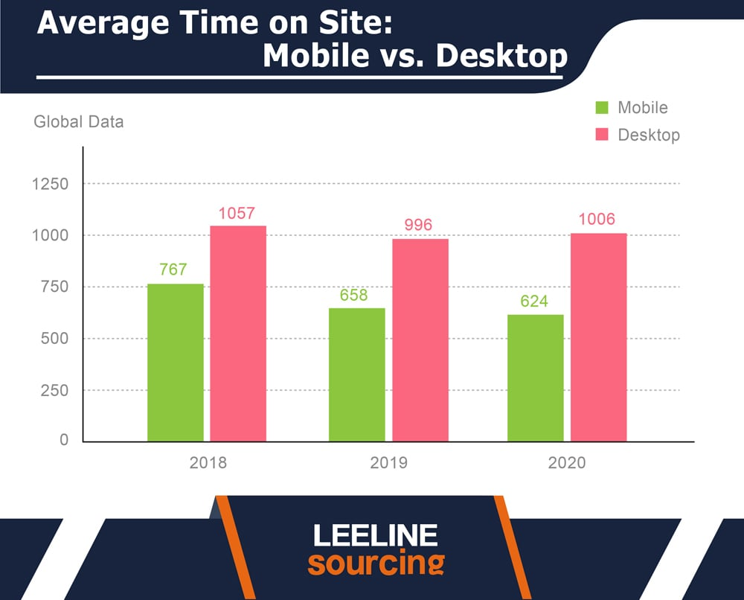

# Chapter 2 Related Works

It should include reviews of previous work by others that are relevant to the project. A review does NOT mean reproducing in detailed material given in textbooks, reports and papers. It DOES mean summarizing the information (with pointing to the references) so that a reader is informed of where to look for the information.

Everything that you write must be your own words and you must cite other people using references.

Summarize the differences between your project and other related reviewed projects and show how your project is different.

# Chapter 3 Methodology

The Methodology chapter should describe how you carried out your project. This includes the techniques, tools, and procedures you used to gather and analyze data, develop your product, or conduct your research. Be clear and detailed so that someone else could replicate your work.

You should mention the software development methodology you used in the Methodology chapter. This is a crucial aspect of your project, as it outlines the overall approach and process you followed to develop the software.

Be sure to:

* **Name the methodology:** Clearly state which methodology you used (e.g., Agile, Scrum, Waterfall).
* **Explain why you chose it:** Briefly justify your choice, highlighting how it aligned with your project's goals, constraints, and requirements.
* **Describe the key practices and phases:** Outline the main steps and activities involved in the methodology, and how you implemented them in your project.
* **Discuss any adaptations or modifications:** If you made any changes to the standard methodology, explain why and how these changes impacted your development process.

Remember that the Methodology chapter should be detailed enough for someone else to understand and potentially replicate your approach. By clearly articulating your software development methodology, you demonstrate a strong understanding of the development process and enhance the credibility of your project.

If your project is a multimedia production, the Methodology chapter should still describe the process you followed, but the focus will shift towards the creative and technical aspects of multimedia production.

The Methodology chapter should include these sections:

* **Name of the methodology:** Clearly state which methodology was used (e.g., Agile, Scrum, Waterfall).
* **Rationale for choosing the methodology:** Briefly justify the choice, highlighting how it aligned with the project's goals, constraints, and requirements.
* **Key practices and phases of the methodology:** Outline the main steps and activities involved in the methodology and how they were implemented in the project.
* **Adaptations or modifications to the standard methodology:** Explain any changes made to the standard methodology, why they were made, and how these changes impacted the development process.
* **Tools and Equipment:** This section should list the specific software, hardware, or other tools used during the project. For software projects, this might include programming languages, IDEs, libraries, and frameworks. For multimedia projects, it could include cameras, microphones, editing software, and animation tools.
* **Timetable:** This section could outline the project's timeline, including key milestones, deadlines, and the duration of each phase. This demonstrates project planning and time management skills.
* **Team Management**
  + **Team Structure and Roles**: Explain how your team was organized and the roles and responsibilities of each team member.
  + **Communication and Collaboration Tools:** Describe the tools and methods you used to communicate and collaborate with your team members (e.g., project management software, version control systems, communication platforms).
  + **Conflict Resolution Strategies**: Briefly discuss how your team handled disagreements or challenges that arose during the project.
  + **Teamwork and Delegation**: Explain how tasks were delegated and how the team worked together to achieve the project's goals.

Remember that these sections should be described clearly and in detail so that the approach can be understood and potentially replicated by someone else.

Remember to adapt these sections to the specific requirements of your project and the expectations of your department or supervisor.

# 

# Chapter # Chapter Name

(include chapters as needed in your project)

After the methodology chapter, you have to include several chapters depending on your project.

For a software development project, you may include the following chapters:

* **Requirements Analysis:** Detailed description of the functional and non-functional requirements gathered and prioritized.
* **System Design:** Description of the overall architecture, design patterns, and key components of the software solution.
* **Implementation and Coding:** Details about the programming languages, tools, and libraries used, as well as coding standards followed.
* **Testing and Evaluation:** Description of the testing strategy, test cases, and results, including unit testing, integration testing, and user acceptance testing.
* **Deployment and Maintenance:** Explanation of how the software will be deployed, monitored, and maintained.
* **User Manual (if applicable):** Instructions on how to install, use, and troubleshoot the software.

Remember that some of these chapters might be combined or split depending on your specific project and its requirements.

For a multimedia production graduation project like creating a short, animated film, you could include chapters such as:

* **Pre-Production:** This would detail the initial stages of your project, including concept development, scriptwriting, storyboarding, and character design.
* **Production:** This chapter would describe the actual creation of your film, including digital drawing, animation, audio recording, and music composition.
* **Post-Production:** This would cover the final stages of your project, such as video editing, sound editing, and visual effects.
* **Testing and Evaluation:** This chapter could describe how you gathered feedback on your film and used it to improve the final product.

Discuss with your supervisor what are the chapters that you may include in your report

# Chapter # Chapter Name

# Chapter # Chapter Name

# Chapter # Conclusions and future works

**Conclusions**

The Conclusions chapter should encapsulate the key findings and outcomes of your IT project, emphasizing their significance and relevance to the field. It should directly address the objectives outlined in the introduction, providing a clear assessment of how well they were achieved. This chapter should highlight the successful implementation of your project, the functionality of the developed system or application, and the potential impact it can have on the IT industry or relevant sector. By summarizing your results and reflecting on your initial goals, you demonstrate the successful completion of your project and its contribution to the advancement of IT knowledge and practice.

**Future Work**

The Future Work chapter should explore potential avenues for further development based on the outcomes of your project. It should identify any limitations encountered during the project and suggest ways to address them in future work. This chapter might include recommendations for enhancements, scalability, or integration with other systems. You could also propose exploring new technologies or methodologies that could build upon your project's foundation. By outlining potential future directions, you highlight the long-term value and relevance of your research, opening doors for continued innovation and exploration in the IT field.

# References

This has the following purposes:

1. To acknowledge the source of material being used.
2. To tell the reader where the confirmation of statements that you have made can be found.
3. To tell the reader where a more extensive or more detailed discussion of the subject (or related subject) can be found.

Use IEEE style for citation / references. Check the video <https://youtu.be/iguguW1MXZ4?si=fzgb-69zMvDSYn_Y> to see how to manage your references in IEEE style

Example:  
Here's an example of a numbered IEEE style citation and reference:

**In-text Citation:**

"As demonstrated in, self-attentive sequential recommendation can effectively model user preferences."

**Reference List Entry:**

W.-C. Kang and J. McAuley, "Self-attentive sequential recommendation," in 2018 IEEE International Conference on Data Mining (ICDM). IEEE, 2018, pp. 197-206.

**Key Points:**

* The in-text citation uses a number in square brackets to refer to the corresponding reference list entry.
* The reference list is ordered numerically, and each entry starts with its reference number in square brackets.
* The rest of the reference entry follows the standard IEEE format, including author names, title, publication venue, year, and page numbers.

**Remember** that while IEEE style is primarily author-date based, it allows for a numbered style option. Check with your department or supervisor to confirm which format they prefer.

# Appendix 1: Information on Appendices

Appendices may be provided to include further details of results, mathematical derivations, certain illustrative parts of program code (e.g. class interfaces), user documentation, log of project milestones.  In particular, if there are technical details of the work done that might be useful to others who wish to build on this work, but that are not sufficiently important to the project as a whole to justify being discussed in the main body of the thesis, then they should be included as appendices.

There is **no expectation** that the examiners should read the appendices as part of the assessment process.  Hence, it is important that any material which will be significant to judging the quality of the thesis or of the project as a whole should be in the main body of the thesis, and not in appendices.